JAVA TUTORIAL-05
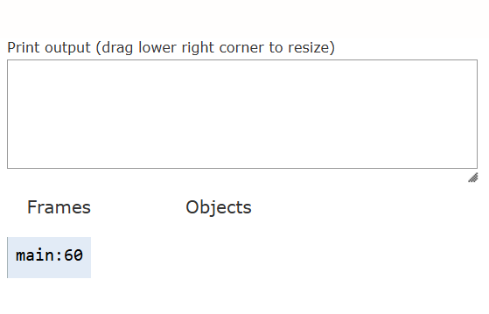
This line tells us that the code starts executing from the line 60 before it goes to the main function.In this we can see inheritance,method overloading.
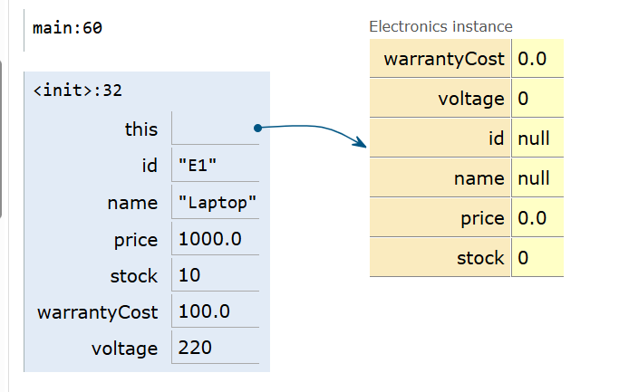
Here,we can see the inheritance.Electronics is the child class of product.Electronics inherits common properties like id,name,price from product but electronics also have its own properties like warrantyCost,voltage.
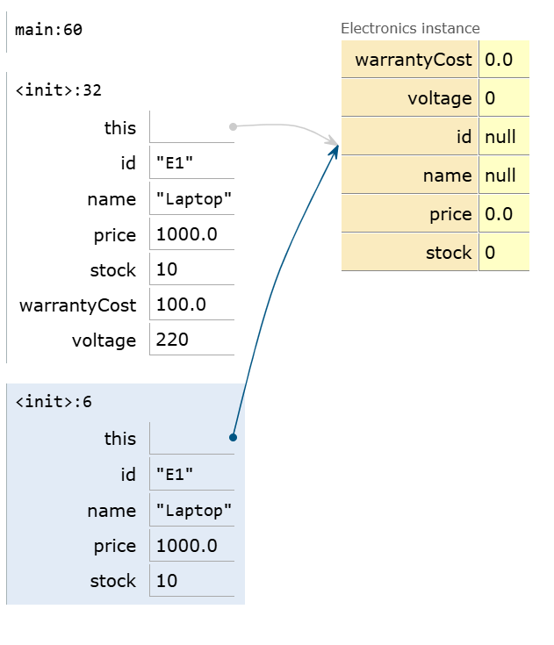
<init>:32 is the Electronics constructor whereas <init>:6 is the Product constructor.
Parent class Product is being called by child class Electronics using super().
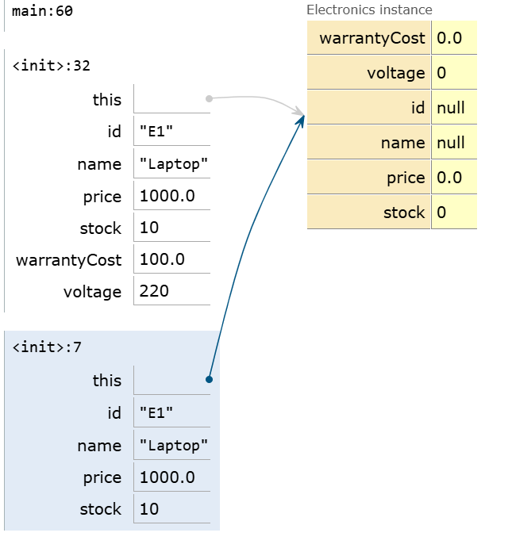
The Product constructor is receiving the values but Electronics is still showing null because still it is not assigned to the object.
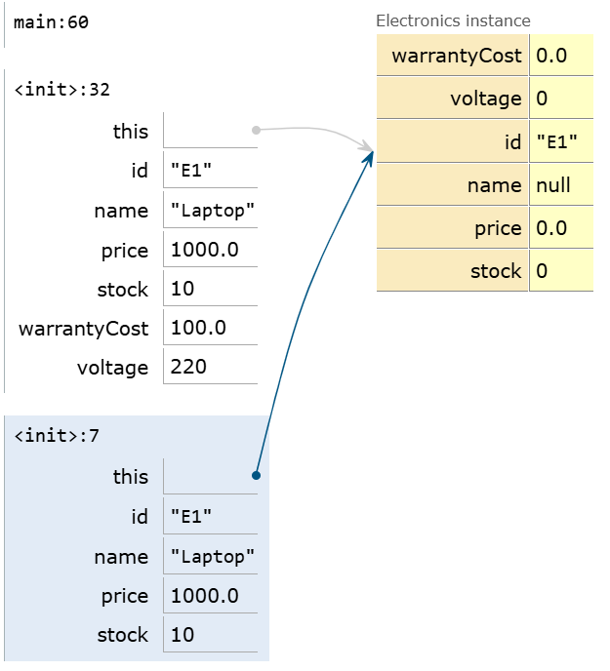
this.id is executed.this.id refers to the object field.Now we can say that id is changed from null to E1 which was present in the product constructor.
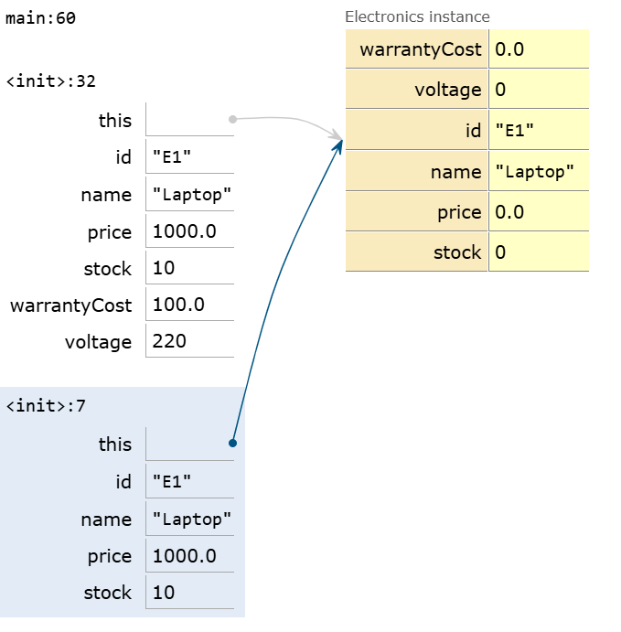
Similarly,here this.name is executed and the name is changed from null to Laptop.
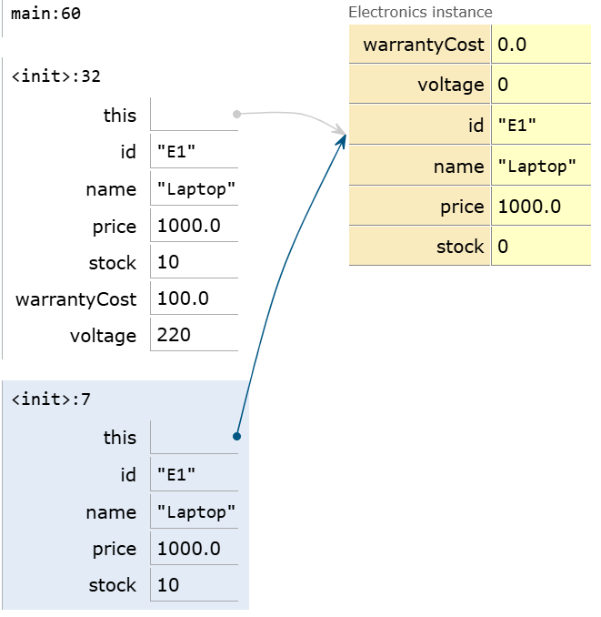
Here,this.price is being executed and the price is changed from 0.0 to 1000.0.
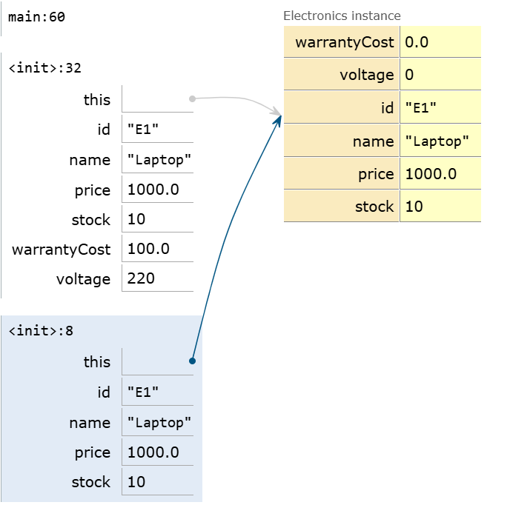
Here,the stock is being executed and the stock is changed from 0 to 10.
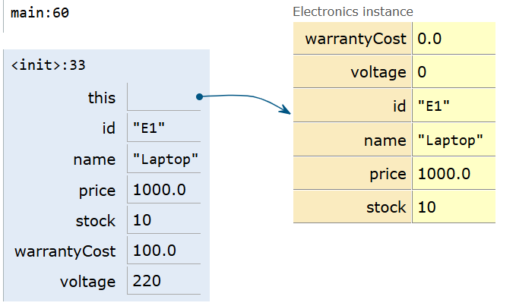
Parent constructor has successfully assigned all the values to the child’s objects field.But warrantyCost,voltage are not assigned because these are its own properties which are not inherited from the parent constructor.
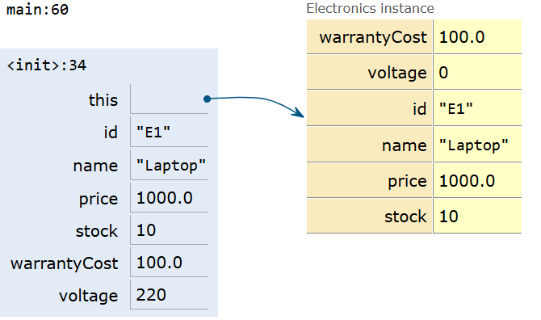
We have assigned the warrantyCost value which is equal to 100.0 .so previously it was 0.0 now it has been initialised to 100.0.
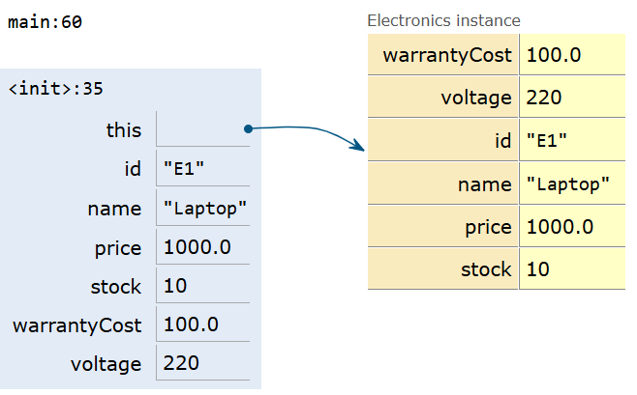
Now we have assigned the value to the voltage which was previously 0.0 now its 220.
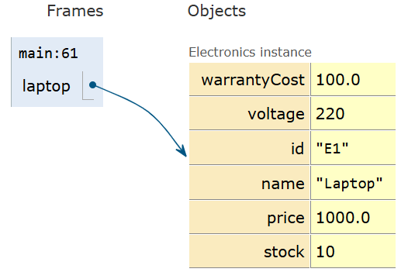
Now we have initialised the Electronics object successfully.Now it returns to the main method.
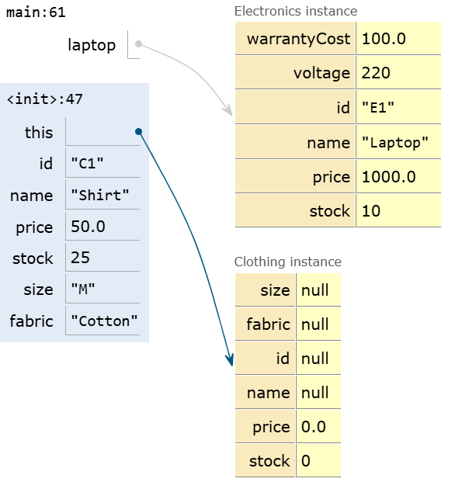
Previously we have completed the Electronics object now program has started creating clothing object.Here,the object field is empty .
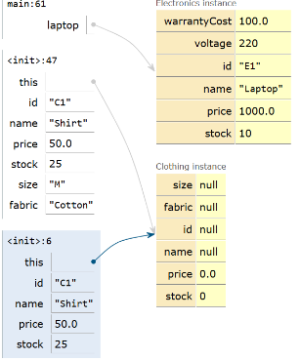
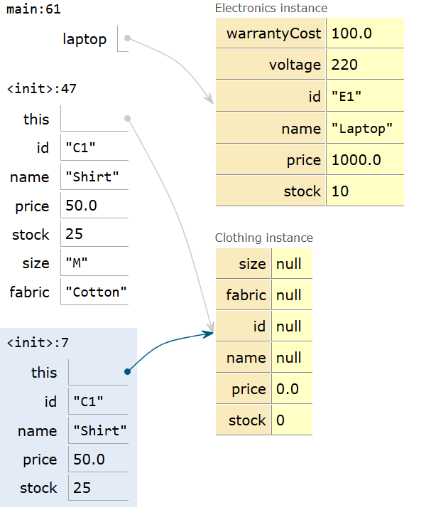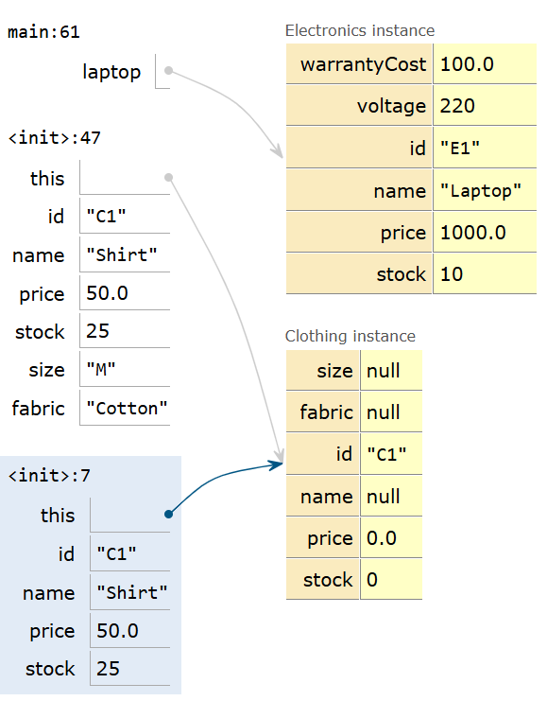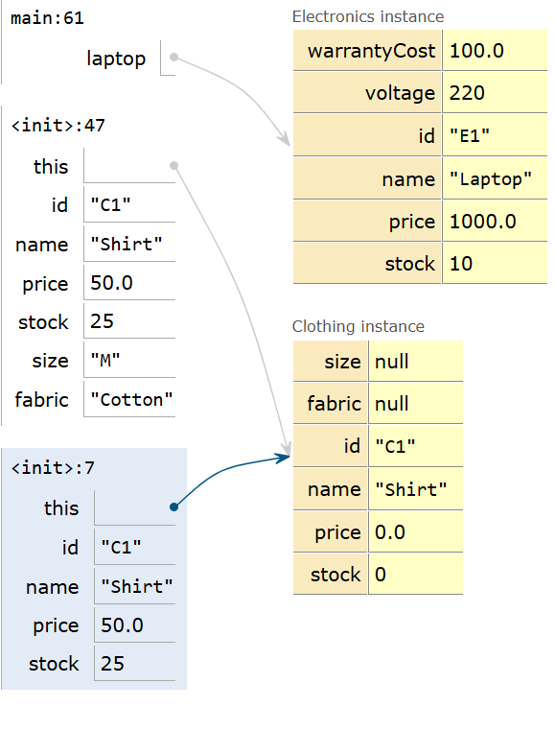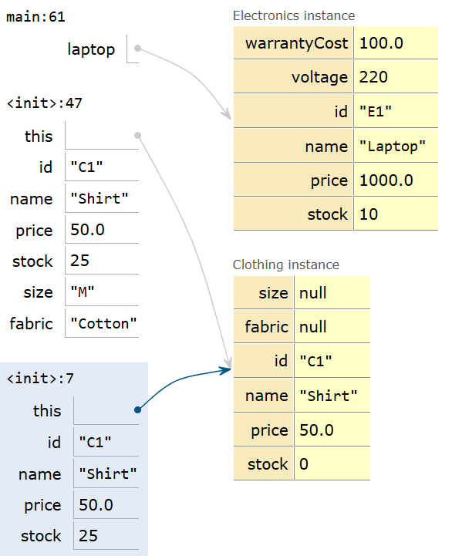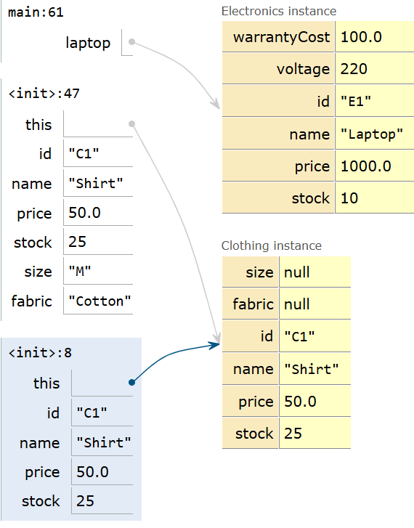
Similar to the Electronics constructor ,Clothing constructor has been created and it has inherited properties from the parent class and received value from it.But size and fabric are not received yet bcz these are its own properties.
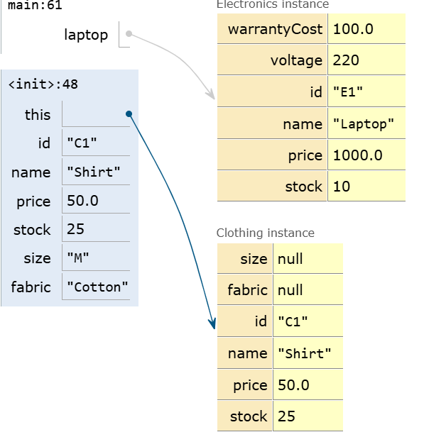
Parent constructor has successfully assigned all the values to the child’s objects field.But fabric and size is still null.
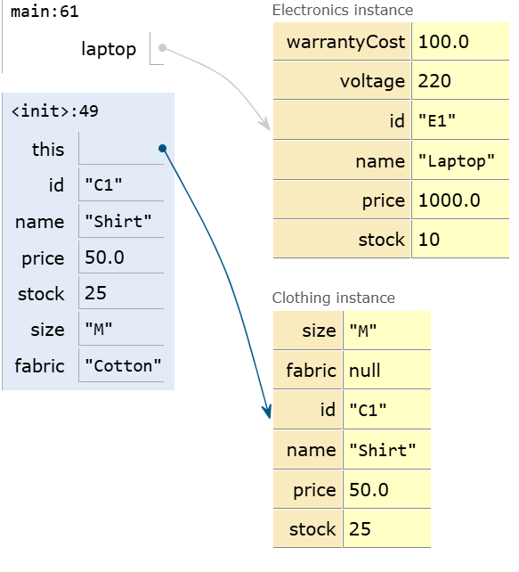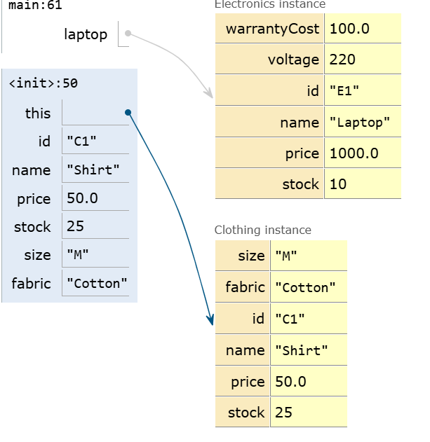
Now we have assigned values to the size and fabric.
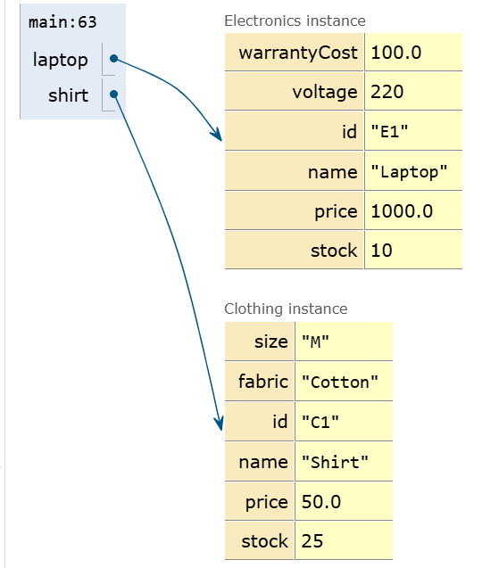
Here both the objects Laptop and shirt are successfully created and initialized.
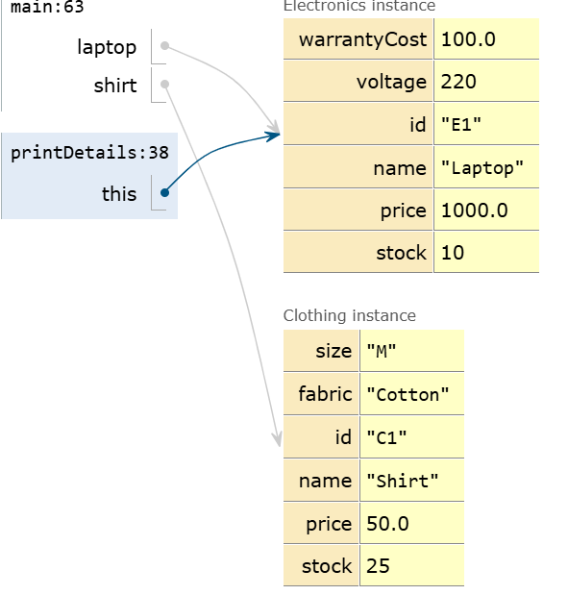
laptop.printDetails(); it means we want the details of laptop.
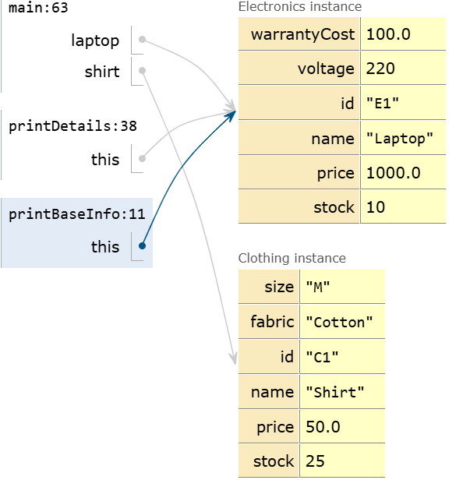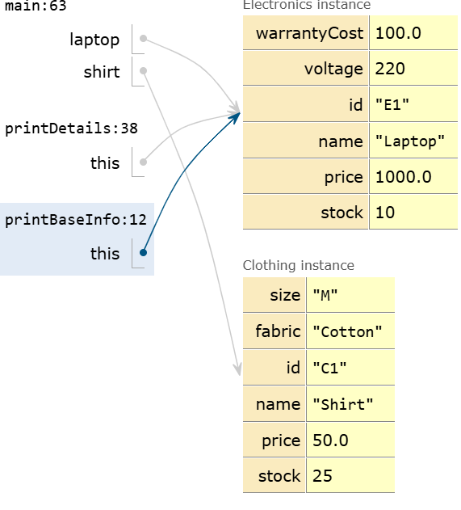
Here,the printBaseInfo(); prints only the basic information like ID,name,price and stock.
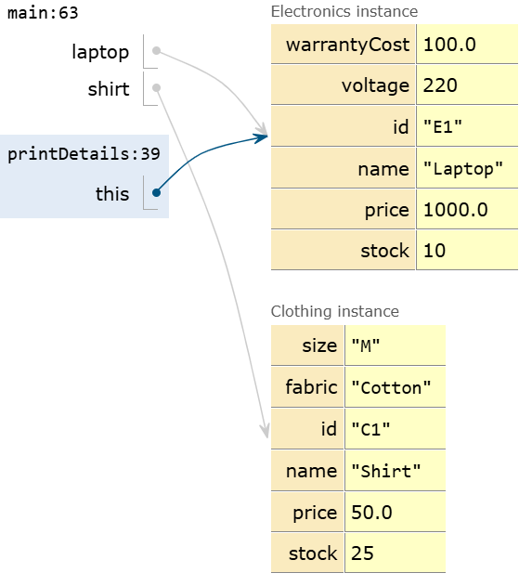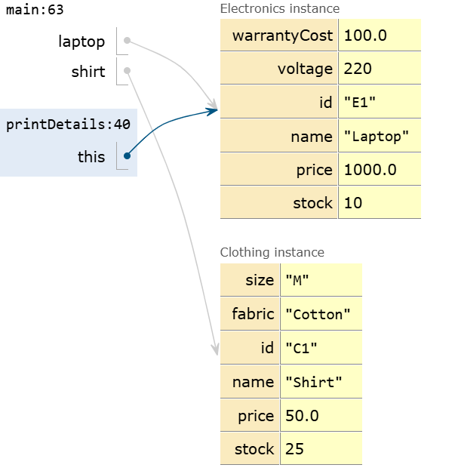
In the main method,we have 2 variables ,laptop and shirt .In printDetails we called method inside that method “this” is pointing to the laptop.
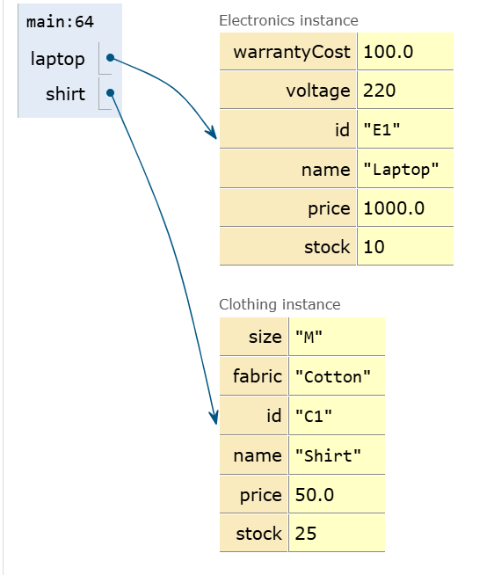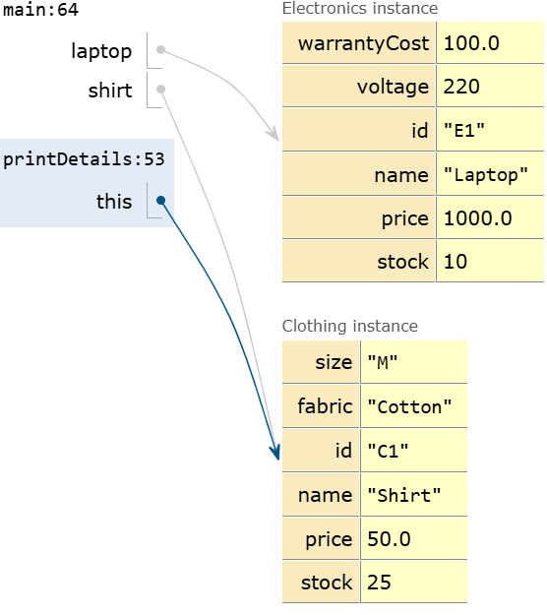
Here,printDetails() has been finished executing so java removes its method frame from the active stack.Here,again printDetails method is called but this time using the shirt object.
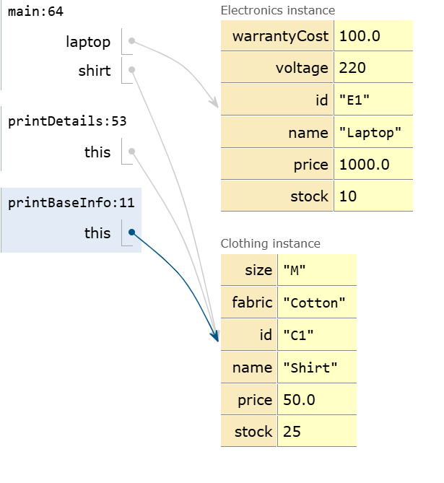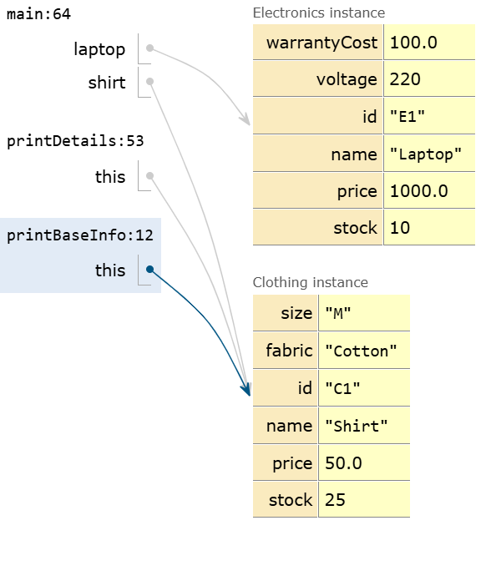
This printBaseInfo() gives only the basic iformation of the shirt object.
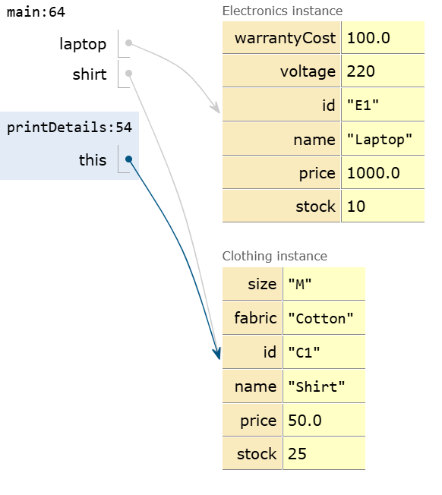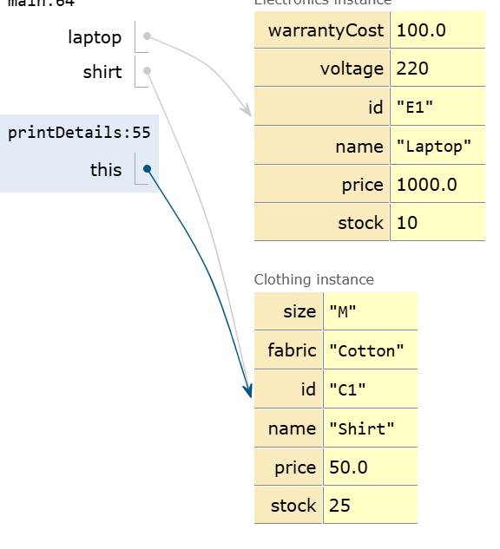
Now we can say that shirt object’s printDetails method almost finished executing.
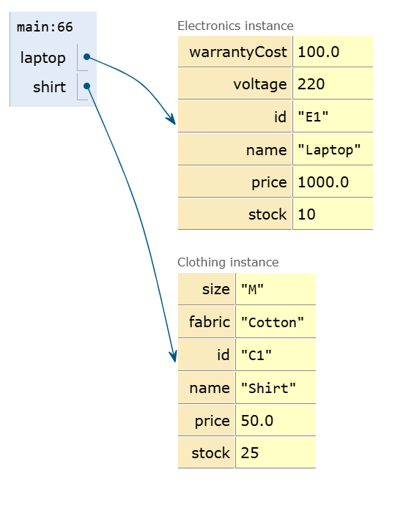
Here printDetails is disappeared bcz method has started executing.Now we can see the details of both objects.Now the program returns to the main() method.
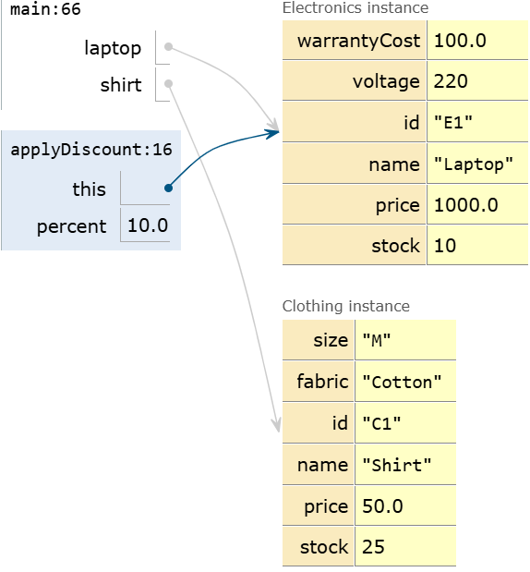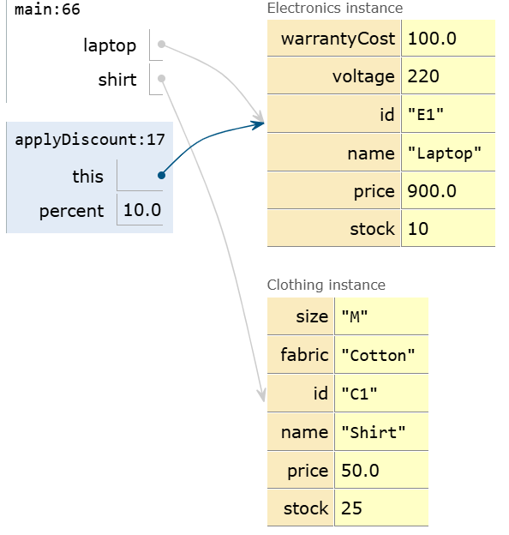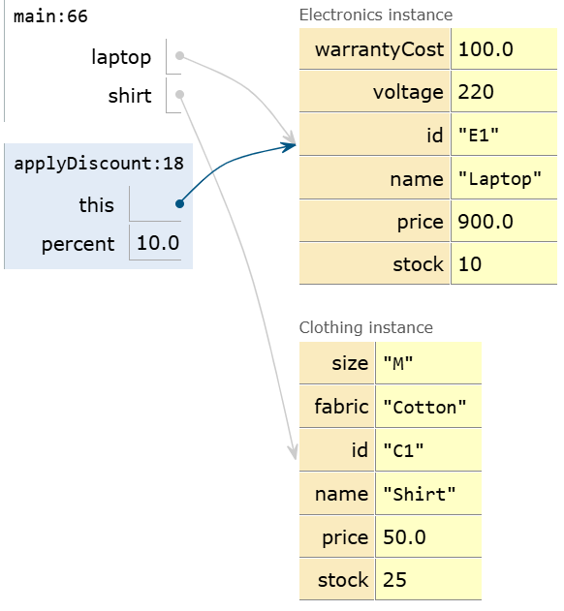
As we have used printDetails for printing the details.Here we have used applyDiscount() to get discount and we also used ‘this’ keyword to get the discount for individual object.
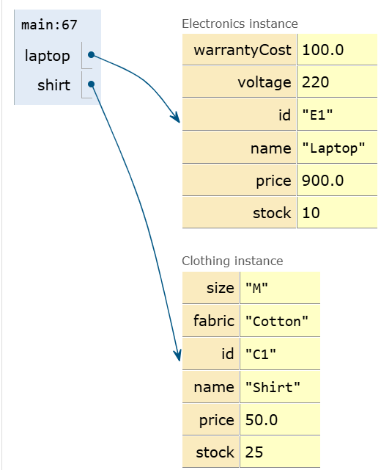
Now we can see that laptop price decreased to 900 after applying 10% discount using applyDiscount() but shirt object remains same because we hv used ‘this’ keyword only to the laptop.
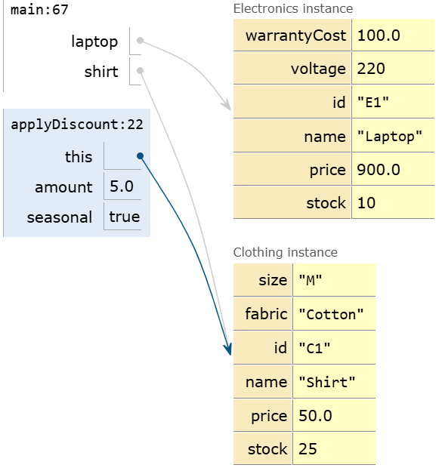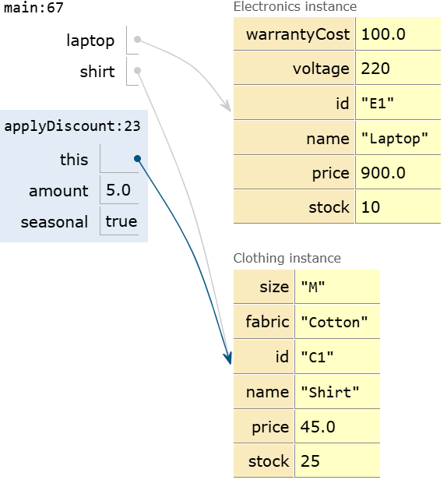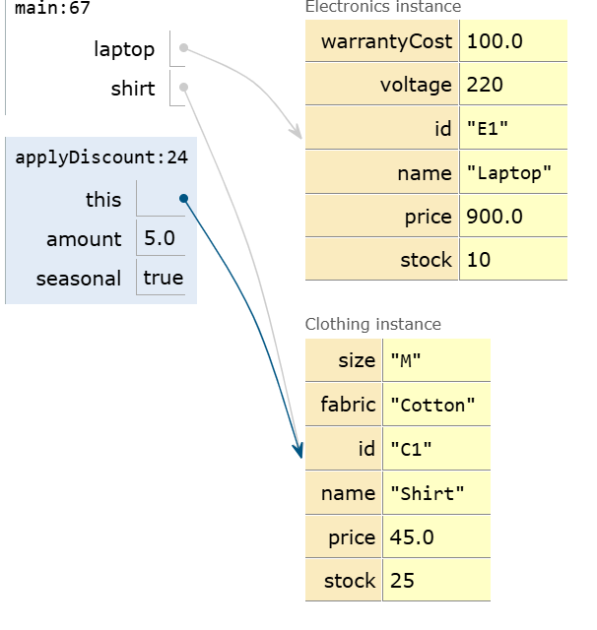
Still applyDiscount() is executing but this time ‘this’ is pointing to the clothing instance.Here amount=5.0 means applying 5% discount for shirt and seasonal true means seasonal discount is enabled.
In the next photo,we can see that seasonal discount has been successfully applied and method has finished executing.
CODE:
class Product {
private String id, name;
private double price;
private int stock;

public Product(String id, String name, double price, int stock) {
this.id = id; this.name = name; this.price = price; this.stock = stock;
}

public void printBaseInfo() {
System.out.println("ID: " + id + ", Name: " + name + ", Price: $" + price + ", Stock: " + stock);
}

// Overload 1: Percentage discount
public void applyDiscount(double percent) {
price -= price * (percent / 100.0);
System.out.println(name + " price after " + percent + "% off: $" + price);
}

// Overload 2: Flat amount discount with seasonal flag
public void applyDiscount(double amount, boolean seasonal) {
price -= amount;
System.out.println((seasonal ? "[Seasonal] " : "") + name + " price after $" + amount + " off: $" + price);
}
}

class Electronics extends Product {
private double warrantyCost;
private int voltage;

public Electronics(String id, String name, double price, int stock, double warrantyCost, int voltage) {
super(id, name, price, stock); // Constructor chaining
this.warrantyCost = warrantyCost;
this.voltage = voltage;
}

public void printDetails() {
super.printBaseInfo(); // Parent method invocation using super
System.out.println("Warranty: $" + warrantyCost + ", Voltage: " + voltage + "V\n");
}
}

class Clothing extends Product {
private String size, fabric;

public Clothing(String id, String name, double price, int stock, String size, String fabric) {
super(id, name, price, stock); // Constructor chaining
this.size = size;
this.fabric = fabric;
}

public void printDetails() {
super.printBaseInfo(); // Parent method invocation using super
System.out.println("Size: " + size + ", Fabric: " + fabric + "\n");
}
}

public class Main {
public static void main(String[] args) {
Electronics laptop = new Electronics("E1", "Laptop", 1000.0, 10, 100.0, 220);
Clothing shirt = new Clothing("C1", "Shirt", 50.0, 25, "M", "Cotton");

laptop.printDetails();
shirt.printDetails();

laptop.applyDiscount(10.0);
shirt.applyDiscount(5.0, true);
}
}

NAME:NISHA R CHANDAN
USN:1BY25AI162
NAME:SHRUTI
USN:1BY25AI236

